**Programming Project Report III**

Yvan Gihoza

010785599

**Problem Statement:**

Our third assignment was to give experience on lighting, where using the Gouraud shading we were to create a background surface.

**Design:**

This project was different than everything we did in the past since there was a lot of math involved. The normal calculation, calculating the vertices colors…But after reviewing the surface and shading codes I was able to have an idea of how the implementation was going to be like.

**Implementation:**

My first approach was to draw a simple surface first and from there I had just to do step by step to finish. The second step was to add the noise, then finally the calculations. I did one light first and then I did the second. The keyboard call back was the last one to be implemented since we did it in the previous assignment, so I knew what to do.

**Testing:**

I tested each step separately and mode by mode. After making sure my light mode 1 was fully functioning I did the second.

**Conclusions:**

The assignment was a success and I was able to implement all the requirements although it was not easy since it took me long to understand what we were asked.

**Testing:**

**1st Run:**

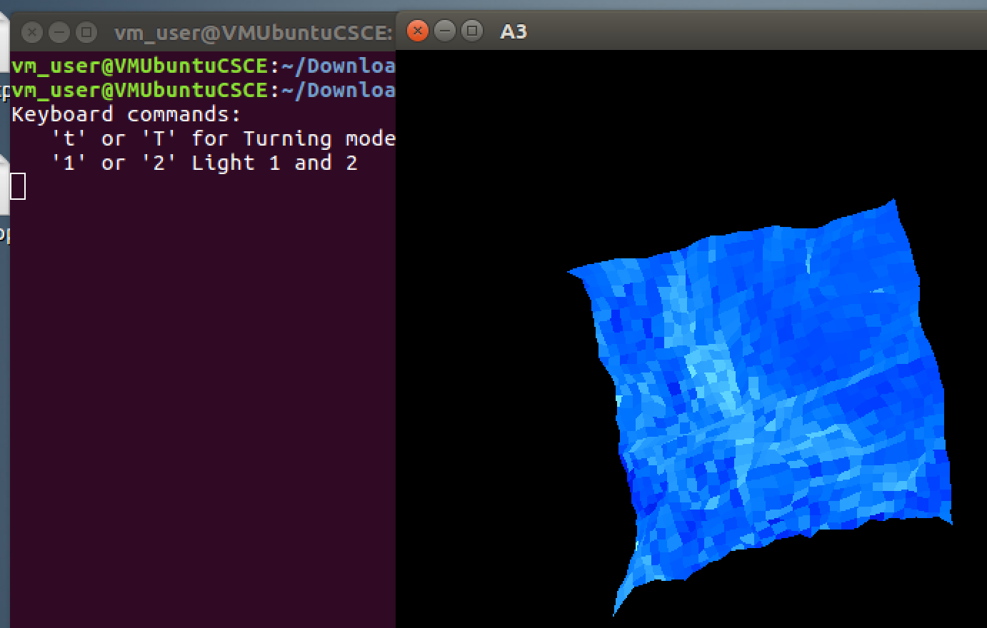

**Changing Light locations**

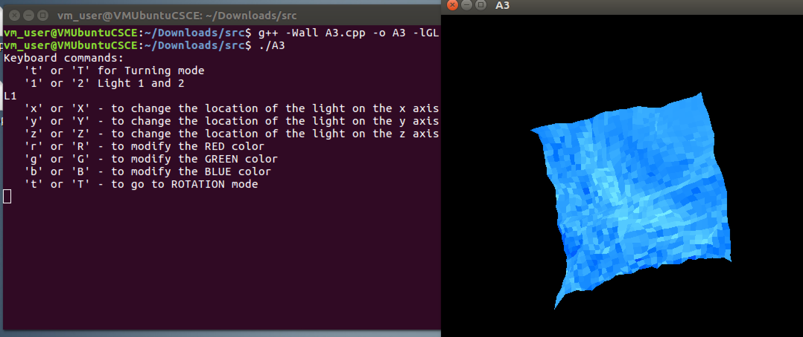

**Changing colors**

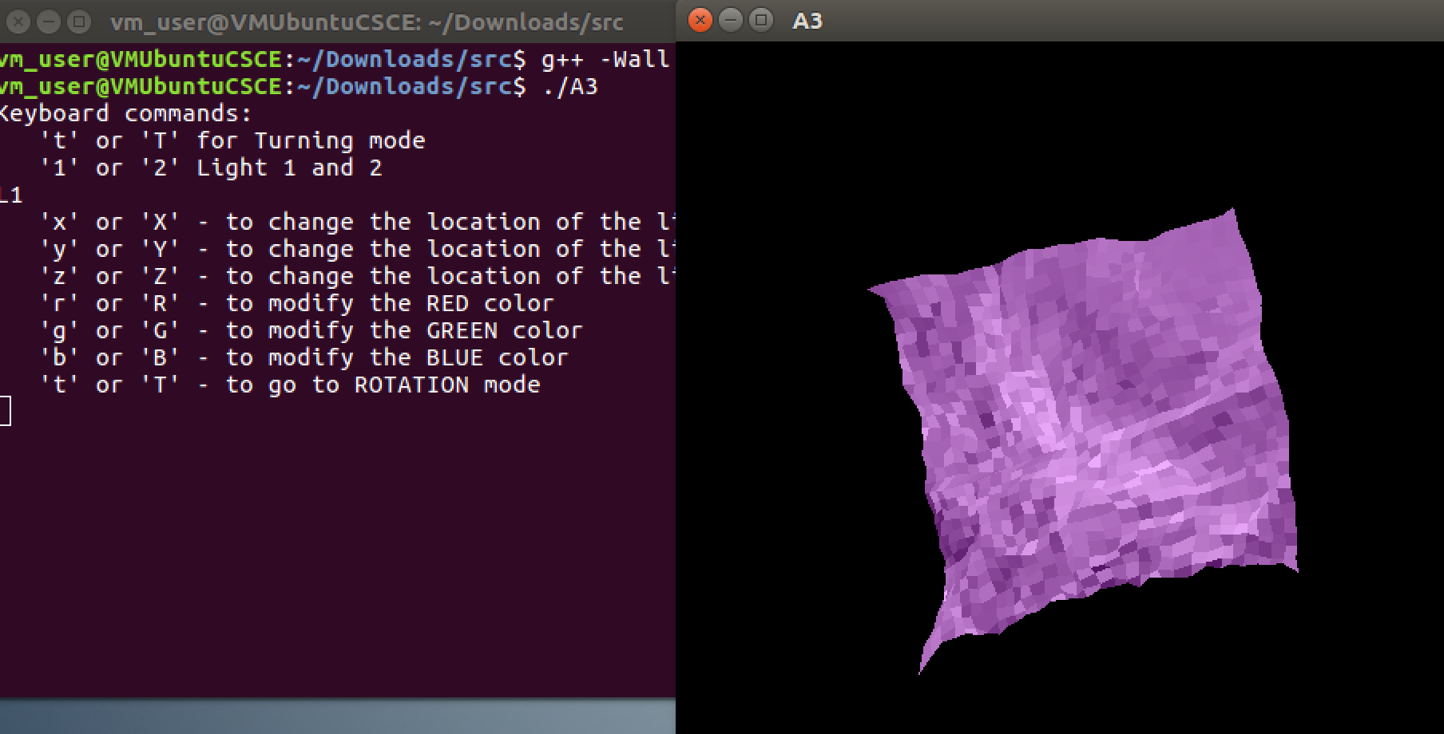

**Rotation, light and color change**

